Name: Pranali Sonawane
Subject: CCNA
Lab – Port Security using DHCP Configuration:
First, we have taken one switch and five PCs. The PCs are connected to the switch using straight-through cables. We used a multilayer switch (Model: 3560-24PS) because it is a Layer 3 switch. The PCs are configured using DHCP.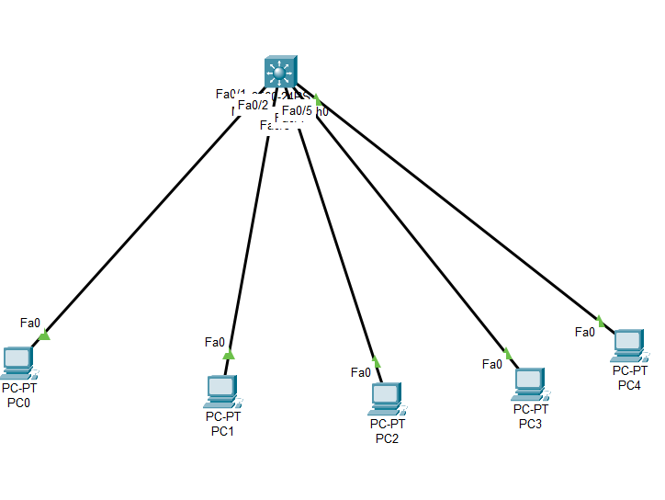
Open Switch 0(3560-24PS) – CLI prompt then type following commands
Switch>enable
Switch#config terminal
Switch (config)#interface fa0/1
Switch (config)#no switchport
Switch (config-if)#ip address 10.0.0.1 255.0.0.0
Switch (config-if)#no shutdown
Switch (config-if)#ip dhcp pool DHCP
Switch (dhcp-config)#network 10.0.0.0 255.0.0.0
Switch (dhcp-config)#default-router 10.0.0.1
Switch (dhcp-config)#exit
Switch (config)#end

Switch>enable
Switch#config terminal
Switch (config)#interface fa0/2
Switch (config)#no switchport
Switch (config-if)#ip address 20.0.0.1 255.0.0.0
Switch (config-if)#no shutdown
Switch (config-if)#ip dhcp pool DHCP
Switch (dhcp-config)#network 20.0.0.0 255.0.0.0
Switch (dhcp-config)#default-router 20.0.0.1
Switch (dhcp-config)#exit
Switch (config)#end

Switch>enable
Switch#config terminal
Switch (config)#interface fa0/3
Switch (config)#no switchport
Switch (config-if)#ip address 30.0.0.1 255.0.0.0
Switch (config-if)#no shutdown
Switch (config-if)#ip dhcp pool DHCP
Switch (dhcp-config)#network 30.0.0.0 255.0.0.0
Switch (dhcp-config)#default-router 30.0.0.1
Switch (dhcp-config)#exit
Switch (config)#end

Switch>enable
Switch#config terminal
Switch (config)#interface fa0/4
Switch (config)#no switchport
Switch (config-if)#ip address 40.0.0.1 255.0.0.0
Switch (config-if)#no shutdown
Switch (config-if)#ip dhcp pool DHCP
Switch (dhcp-config)#network 40.0.0.0 255.0.0.0
Switch (dhcp-config)#default-router 40.0.0.1
Switch (dhcp-config)#exit
Switch (config)#end

Switch>enable
Switch#config terminal
Switch (config)#interface fa0/5
Switch (config)#no switchport
Switch (config-if)#ip address 50.0.0.1 255.0.0.0
Switch (config-if)#no shutdown
Switch (config-if)#ip dhcp pool DHCP
Switch (dhcp-config)#network 50.0.0.0 255.0.0.0
Switch (dhcp-config)#default-router 50.0.0.1
Switch (dhcp-config)#exit
Switch (config)#end
Port Security:
Switch (config)#interface fa0/1
Switch (config-if)#switchport
Switch (config-if)#switchport mode access
Switch (config-if)#switchport port-security
Switch (config-if)#switchport port-security mac-address sticky
Switch (config-if)#switchport port-security maximum 1
Switch (config-if)#switchport port-security violation shutdown
Switch (config-if)#do sh his
Switch (config-if)#exit
Switch (config)#exit
Switch# show port-security

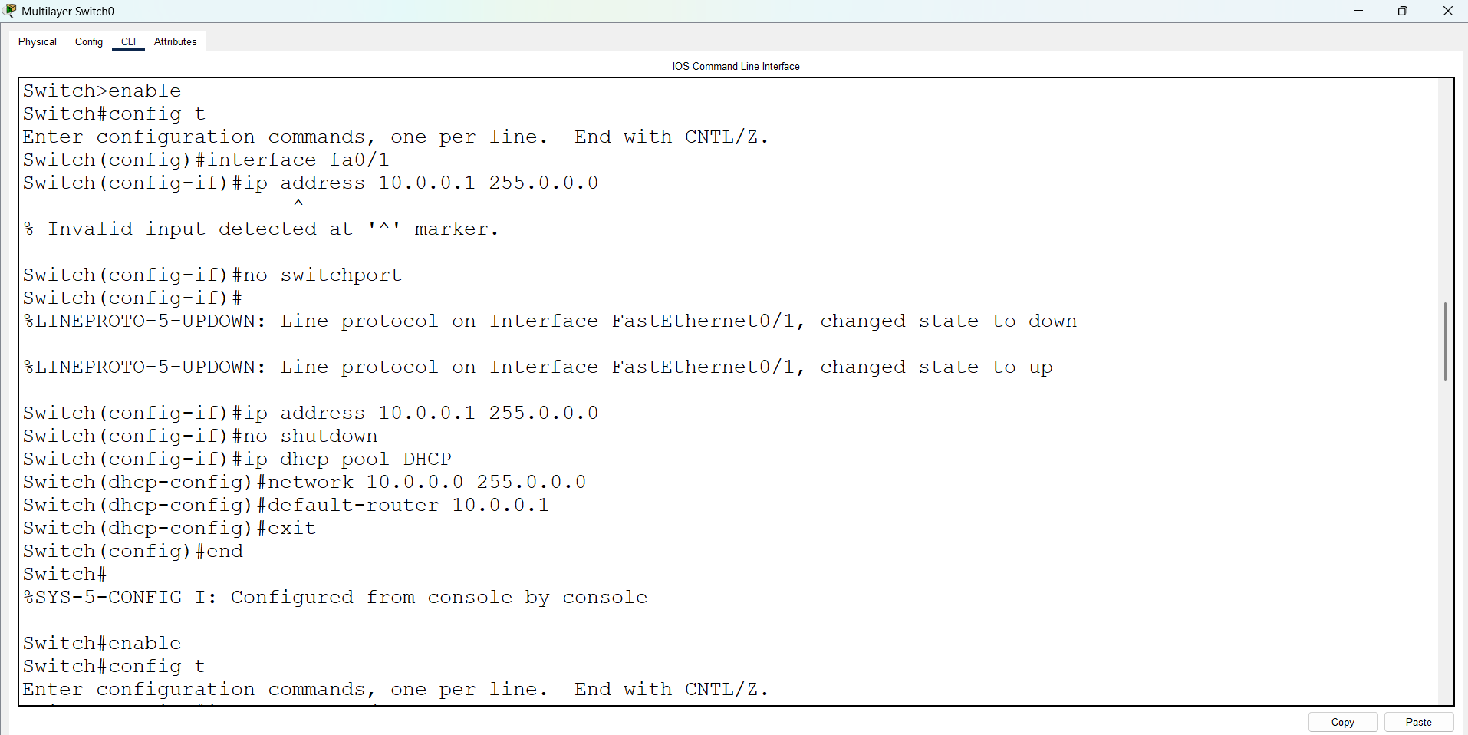
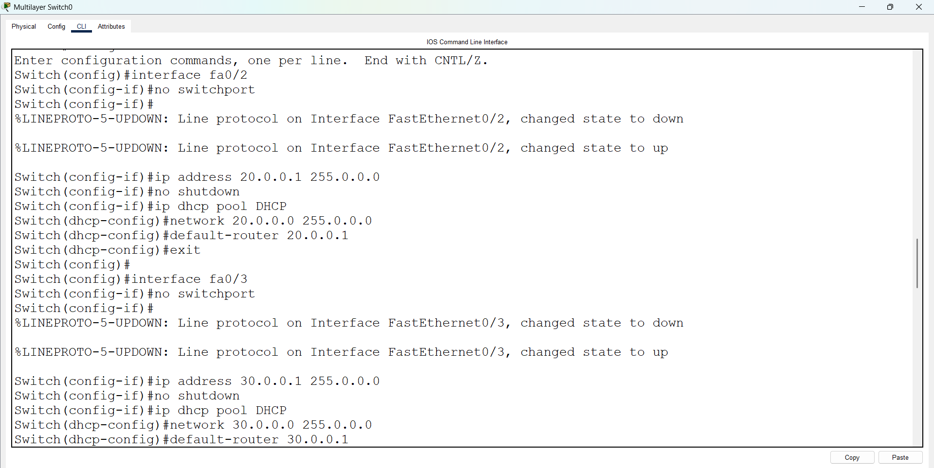
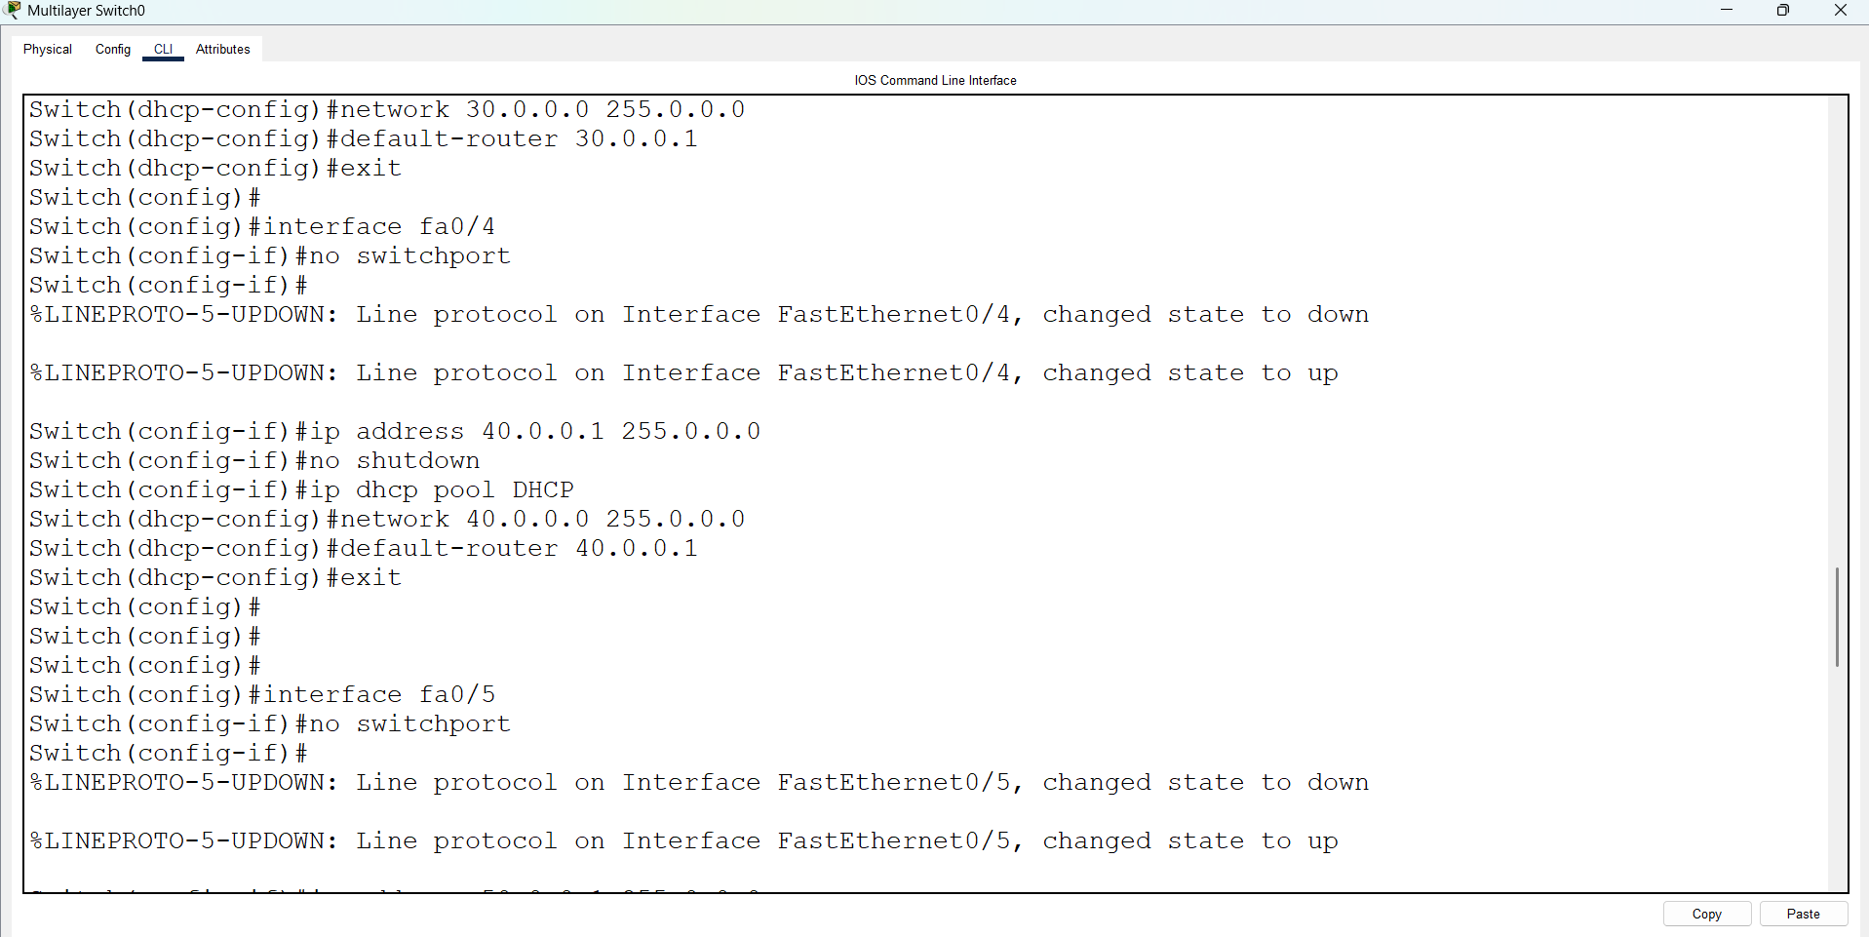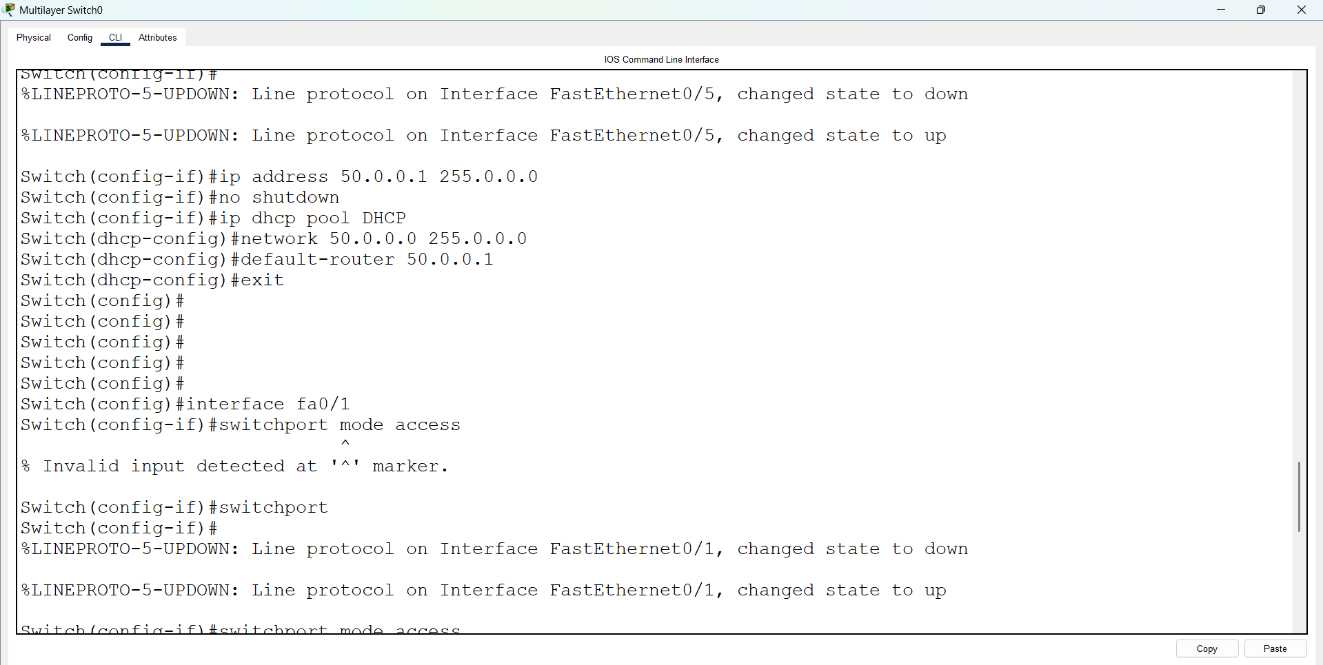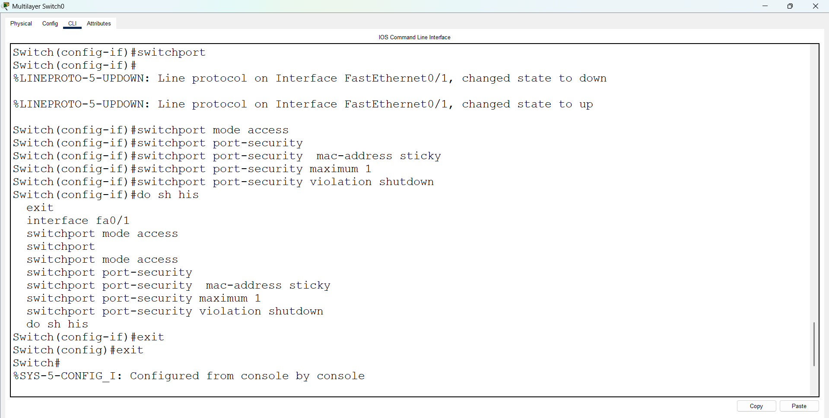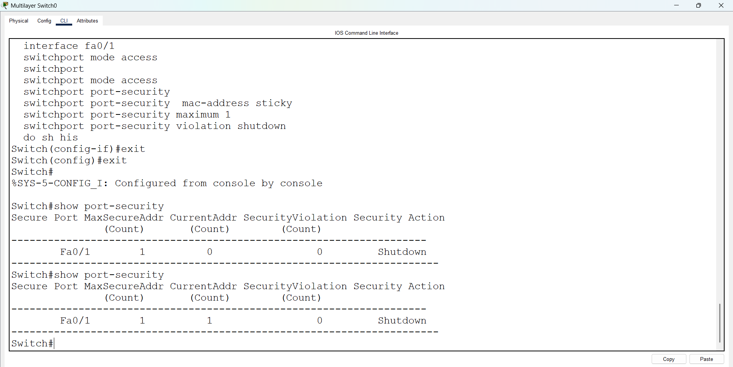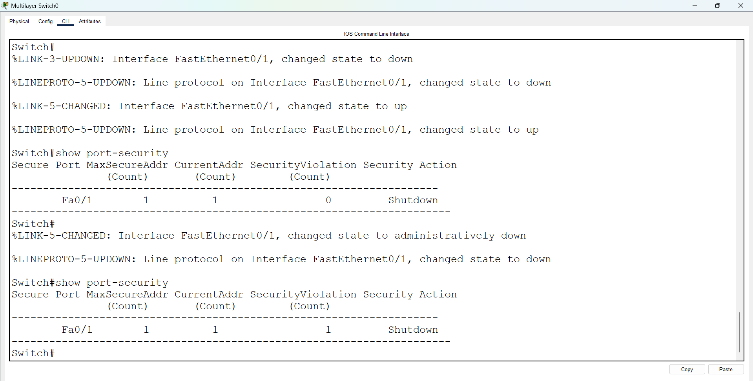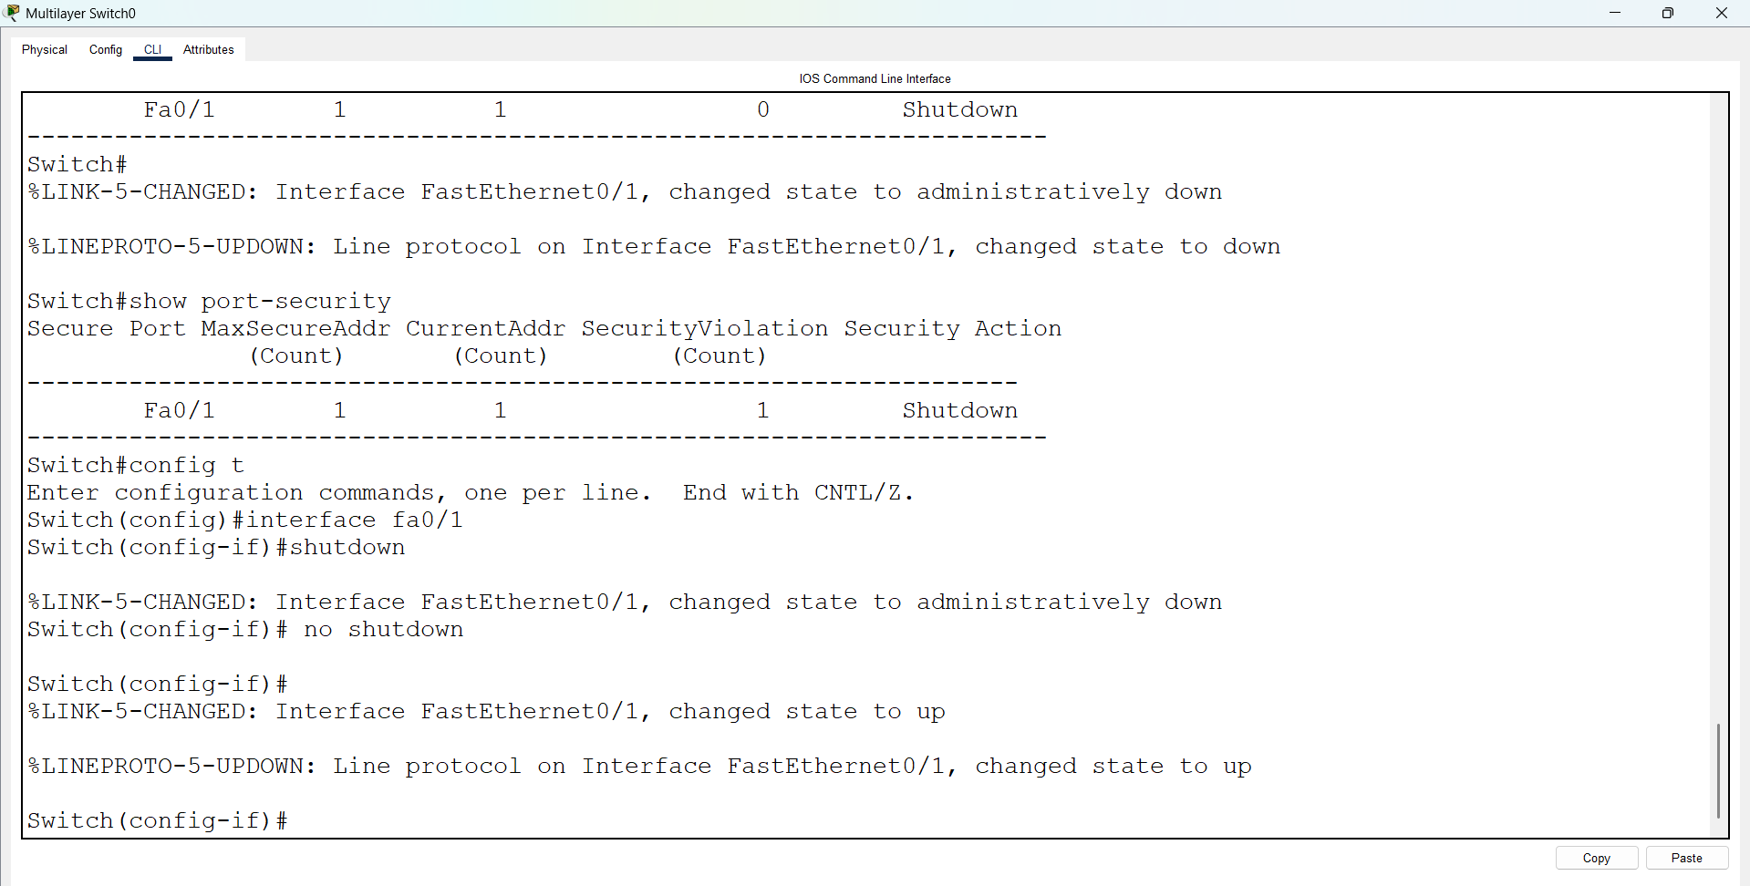
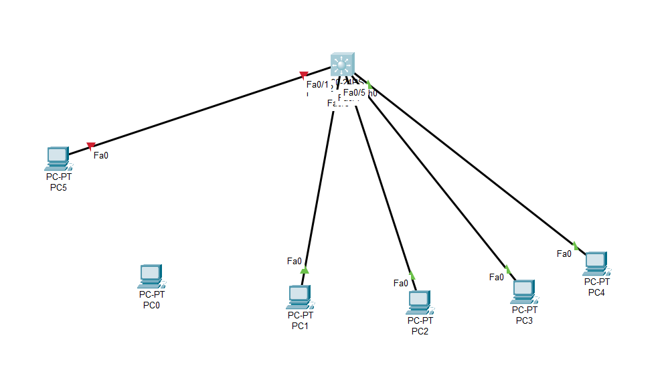
After pinging the PCs, the current address count is 1. In the diagram above, when PC0 is moved from port Fa0/1 to PC5, it shows a red color (indicating a connection issue). After reconnecting PC0, enter the following commands:
Switch> enable
Switch# configure terminal
Switch(config)# interface fa0/1
Switch(config-if)# shutdown
Switch(config-if)# no shutdown
